# Apply mask to BFI in FIJI

Last updated 16Jul2015, [liliamesina@yahoo.com](mailto:liliamesina@yahoo.com)

1. Open the BFI and the stained image in Fiji and draw the ROI

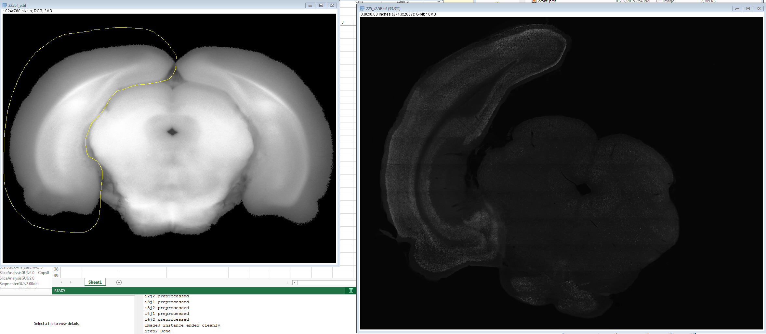

1. Select in Fiji menu Edit>Selection>CreateMask
2. Select Edit>Invert for the mask, so the background becomes black
3. Select Process>ImageCalculator and select parameters as below then press OK

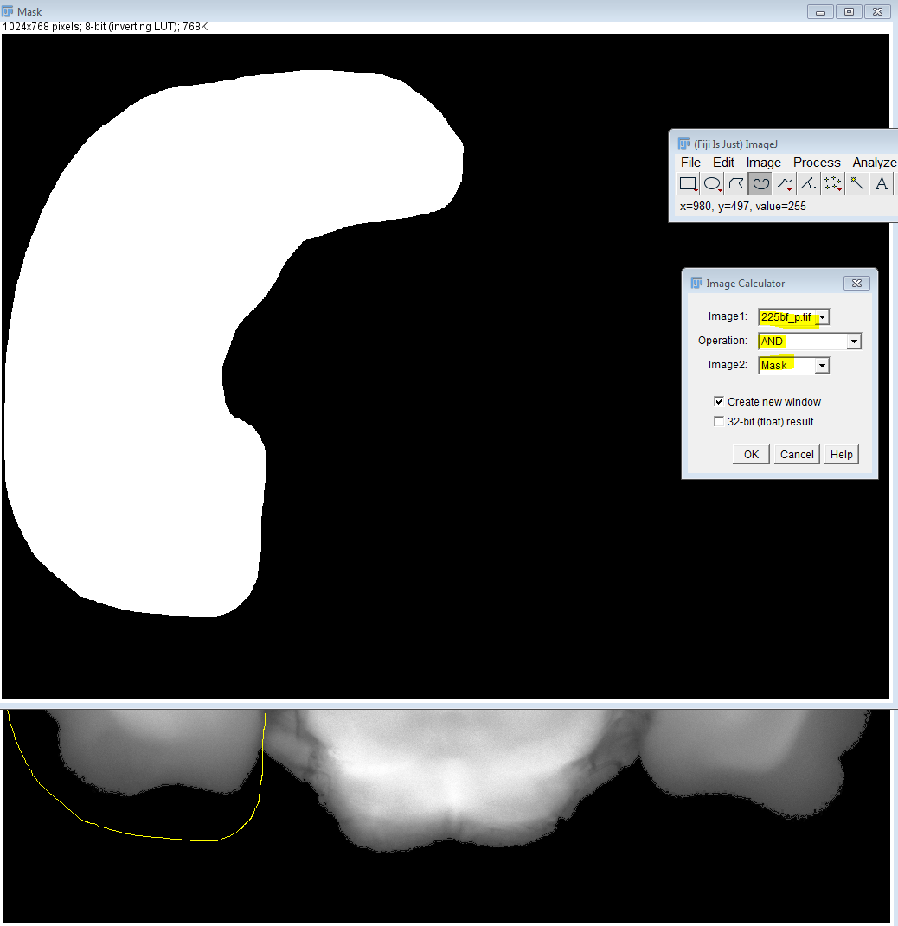

1. The result image

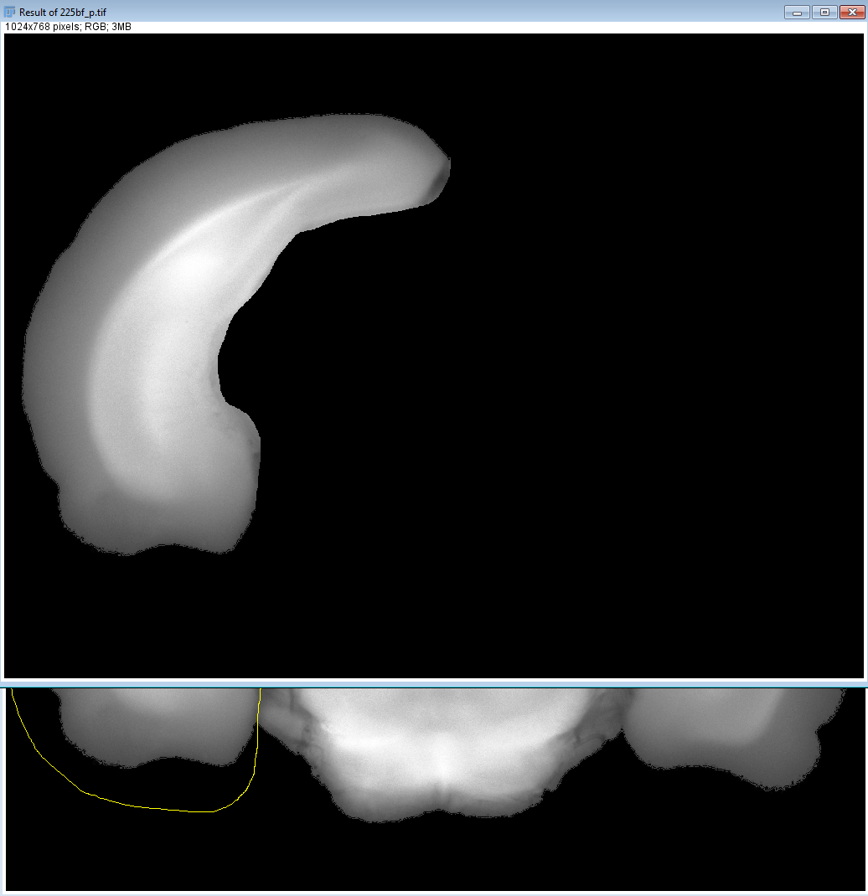

1. Save to the same location under the same BFI file name with M at the end (for example 225bf_pM.tif). Done.